1. **WRITE A BLOG ON DIFFERENCE BETWEEN HTTP1.1 VS HTTP2**

|  |  |
| --- | --- |
| HTTP 1.1 | HTTP 2 |
| Developed by Timothy Berners-Lee in 1989 | HTTP/2 was developed by the HTTP Working Group |
| There is head of line blocking that blocks all the requests behind it until it doesn’t get its all resources. | It allows multiplexing so one TCP connection is required for multiple requests. |
| It uses requests resource inlining for use getting multiple pages. | It uses PUSH frame by server that collects all multiple pages. |
| It compresses data by itself. | It uses HPACK for data compression. |
| Ithe usest works on the textual format. | It works on the binary protocal. |
| HTTP requests and responses can be pipelined on a connection. | Http pipelining is a technique in which multiple http requests are sent on a single TCP connection without waiting for the corresponding responses |
| HTTP 1.1 is the latest version of Hypertext Transfer Protocol | HTTP/2 began as the SPDY protocol |

2) **WRITE A BLOG ABOUT OBJECTS AND ITS INTERNAL REPRESENTATION IN JAVASCRIPT**

In JavaScript, an object is a standalone entity, with properties and type. Compare it with a cup, for example. A cup is an object, with properties. A cup has a color, a design, weight, a material it is made of, etc. The same way, JavaScript objects can have properties, which define their characteristics.

Creating Objects in JavaScript:

1. By object literal
2. By creating instance of Object directly (using new keyword)

By object literal:

The syntax of creating object using object literal is given below:



Property and value is separated by colon(:).

Example:

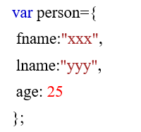

By creating instance of Object directly (using new keyword):

The syntax of creating object directly is given below:



Here, new keyword is used to create object.

Example:

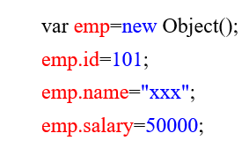

Accessing JavaScript Objects:

The syntax for accessing the property of an object is:

*objectName.property*

or

*objectName*[“*property*”]

Accessing ‘fname’ from example 1 using dot operator,



Accessing ‘name’ form example 2 using [],

